Githublink - <https://github.com/punit23121999/evaluation4unit3>

Drivelink - <https://drive.google.com/drive/folders/1OelgD_-9cEcV_FkuETqYtjwmjGmb6b44?usp=sharing>

npm -i init

npm install cypress –save-dev

npx cypress open

PS C:\Users\puneet kumar\OneDrive\Desktop\evaluation4unit3> npm -i init

This utility will walk you through creating a package.json file.

It only covers the most common items, and tries to guess sensible defaults.

See `npm help init` for definitive documentation on these fields

and exactly what they do.

Use `npm install <pkg>` afterwards to install a package and

save it as a dependency in the package.json file.

Press ^C at any time to quit.

package name: (evaluation4unit3)

version: (1.0.0)

description:

entry point: (index.js)

test command:

git repository:

keywords:

author:

license: (ISC)

About to write to C:\Users\puneet kumar\OneDrive\Desktop\evaluation4unit3\package.json:

{

"name": "evaluation4unit3",

"version": "1.0.0",

"main": "index.js",

"scripts": {

"test": "echo \"Error: no test specified\" && exit 1"

},

"author": "",

"license": "ISC",

"description": ""

}

Is this OK? (yes)

PS C:\Users\puneet kumar\OneDrive\Desktop\evaluation4unit3> mpm install cypress --save-dev

mpm : The term 'mpm' is not recognized as the name of a cmdlet,

function, script file, or operable program. Check the spelling of the

name, or if a path was included, verify that the path is correct and

try again.

At line:1 char:1

+ mpm install cypress --save-dev

+ ~~~

+ CategoryInfo : ObjectNotFound: (mpm:String) [], CommandN

otFoundException

+ FullyQualifiedErrorId : CommandNotFoundException

PS C:\Users\puneet kumar\OneDrive\Desktop\evaluation4unit3> npm install cypress --save-dev

added 173 packages, and audited 174 packages in 2m

39 packages are looking for funding

run `npm fund` for details

found 0 vulnerabilities

PS C:\Users\puneet kumar\OneDrive\Desktop\evaluation4unit3> npx cypress open

It looks like this is your first time using Cypress: 13.15.0

✔ Verified Cypress! C:\Users\puneet kumar\AppData\Local\Cypress\Cache…

Opening Cypress...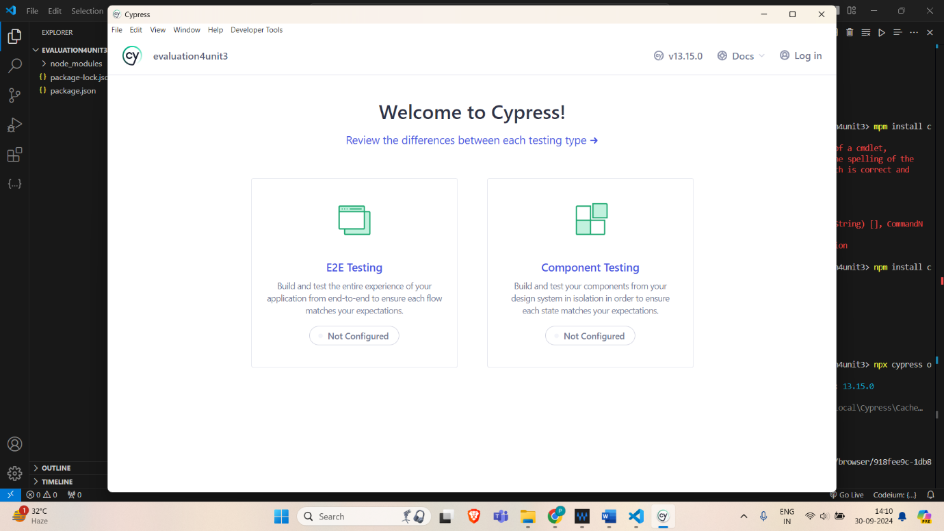

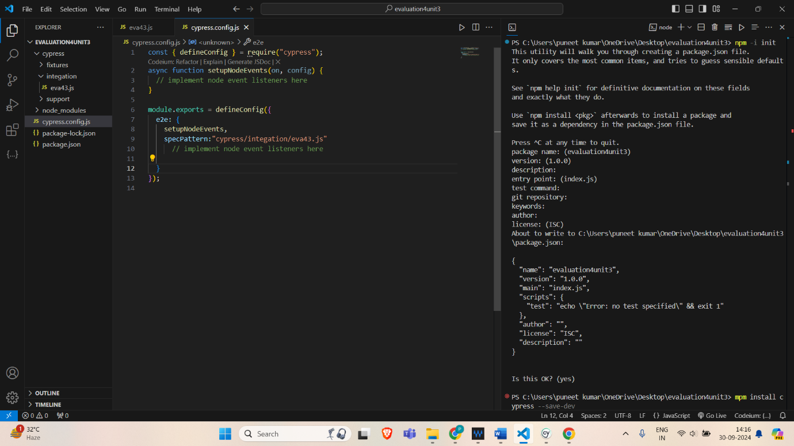

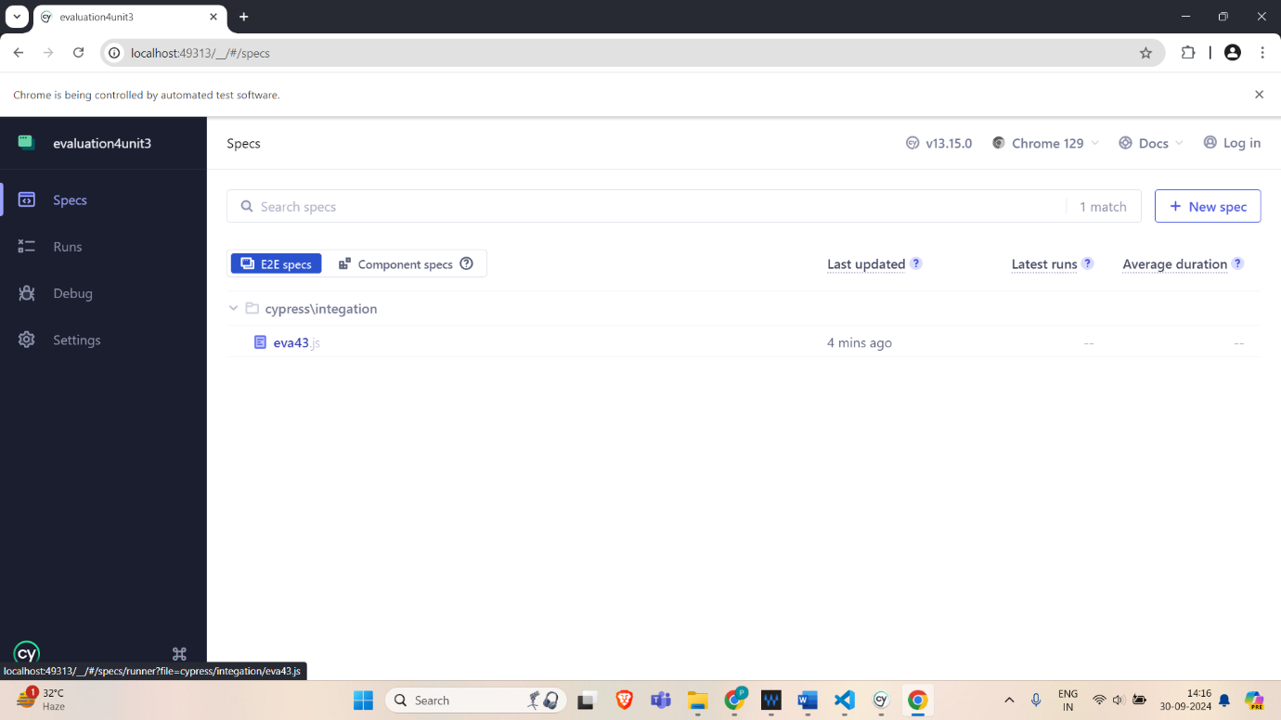

npm install -D cypress-xpath

e2e--- require('cypress-xpath');

cucumber install

npm install --save-dev cypress-cucumber-preprocessor

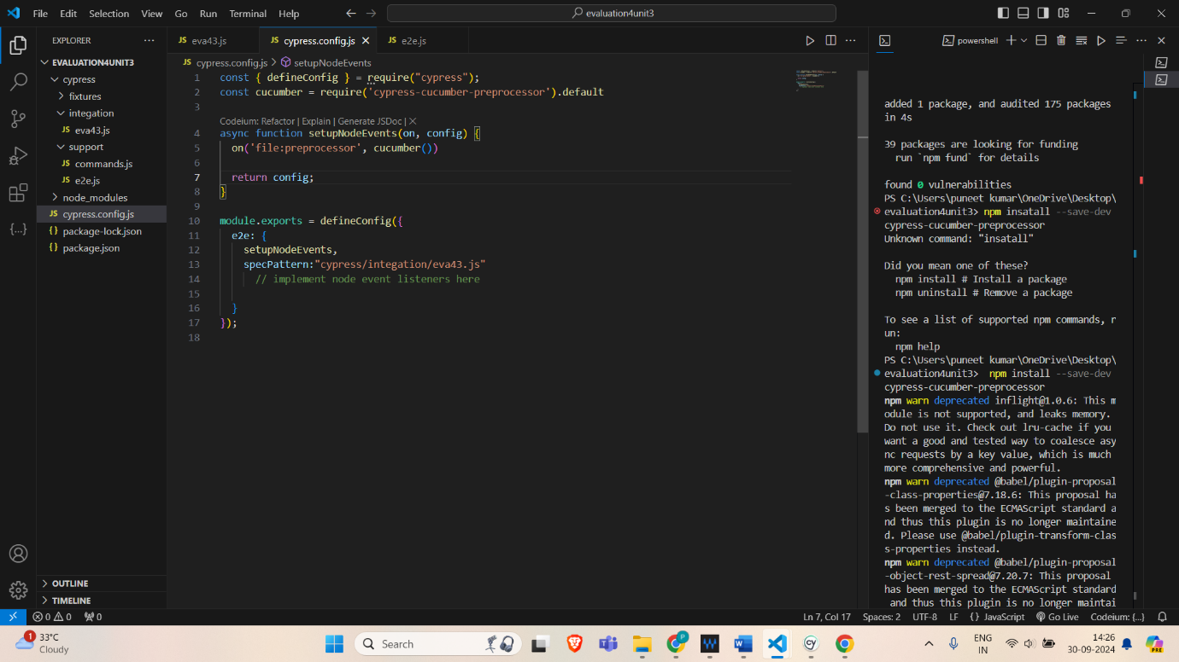

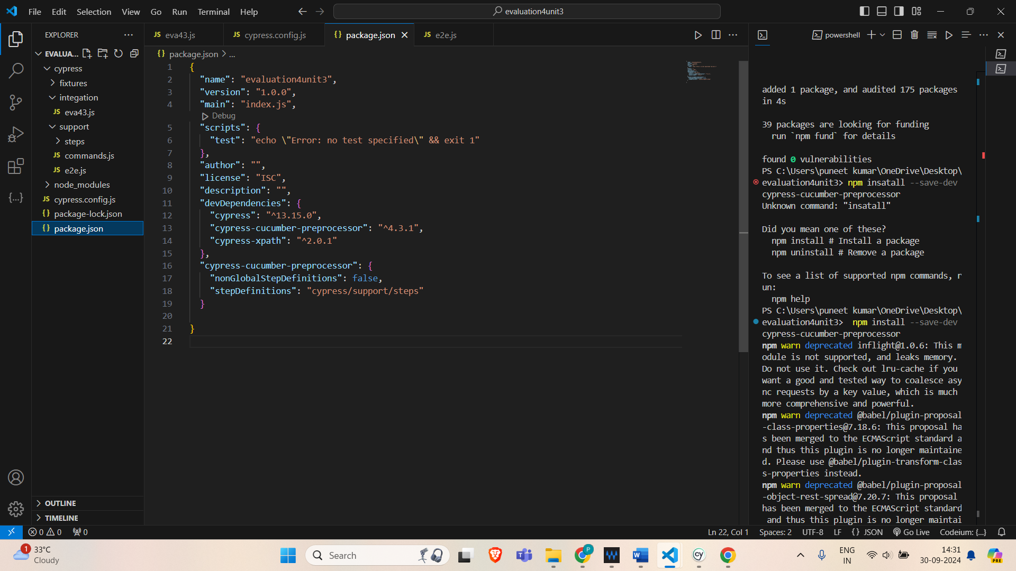

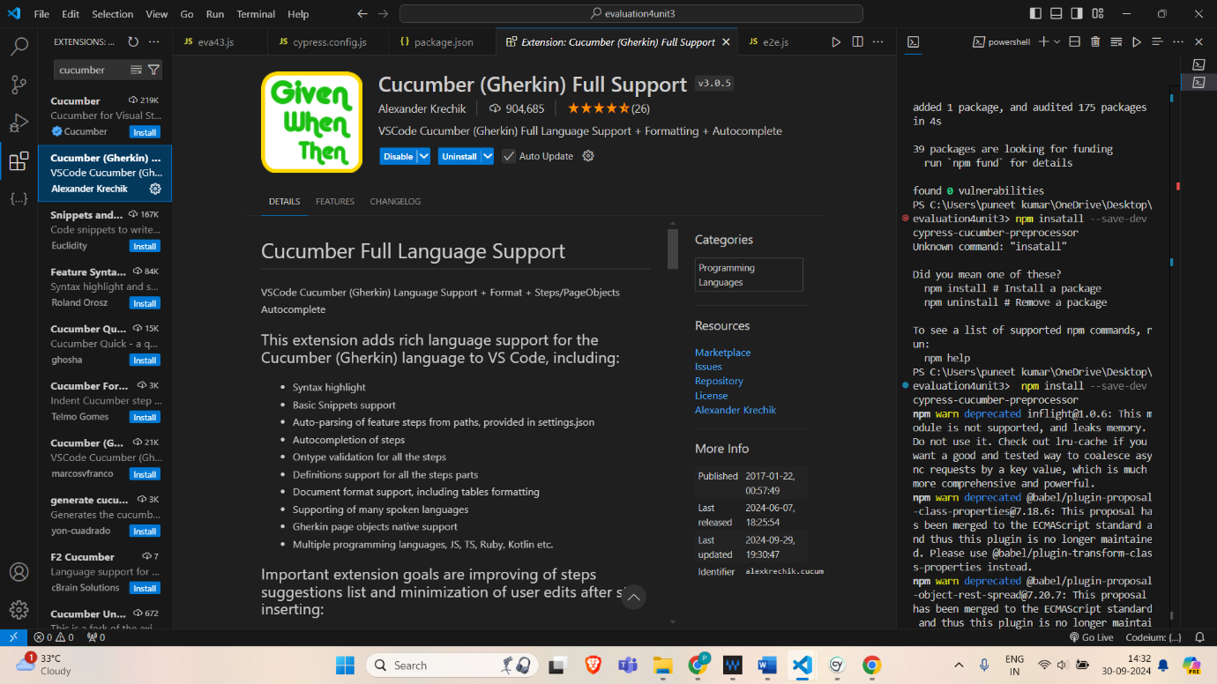

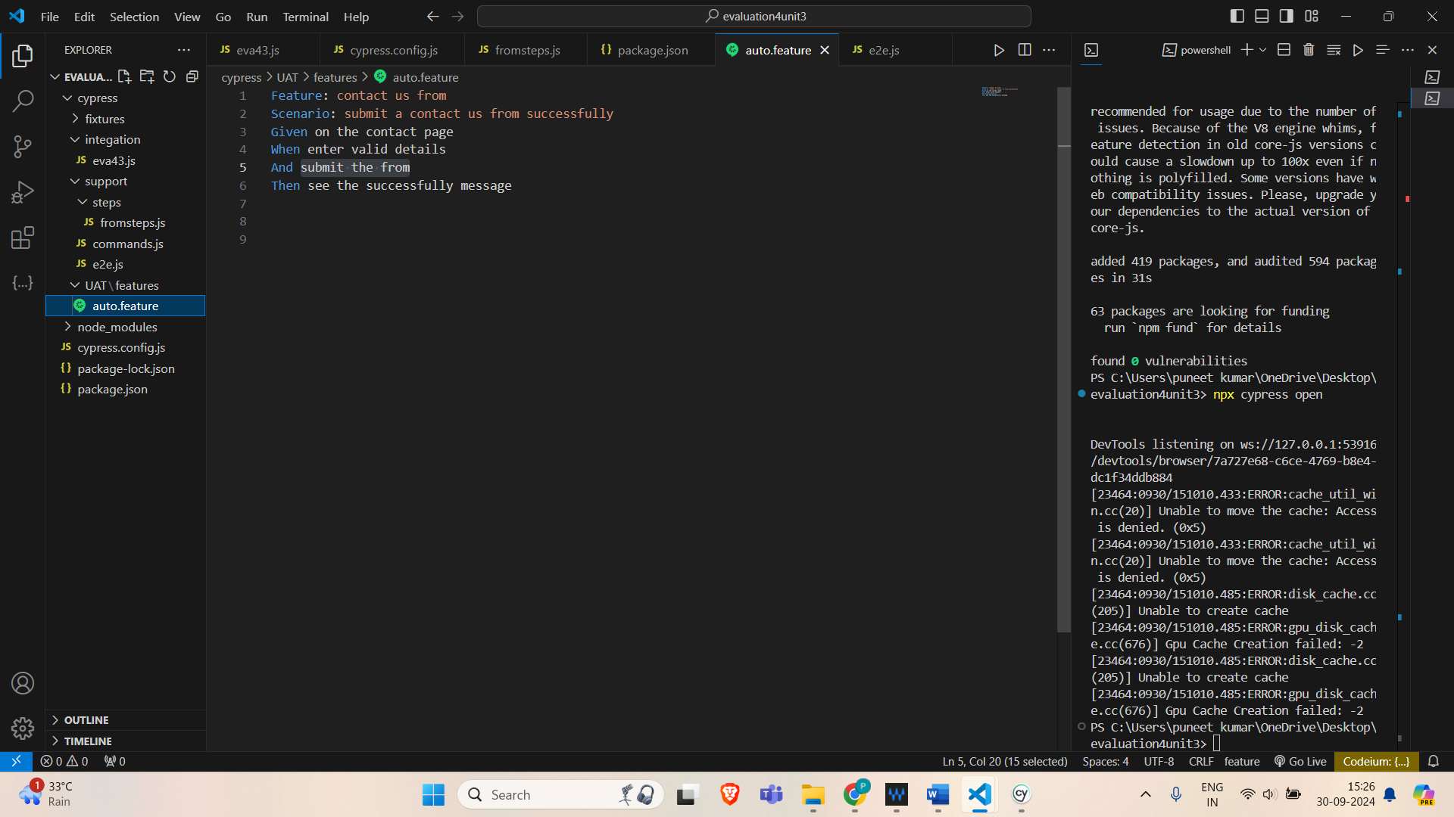

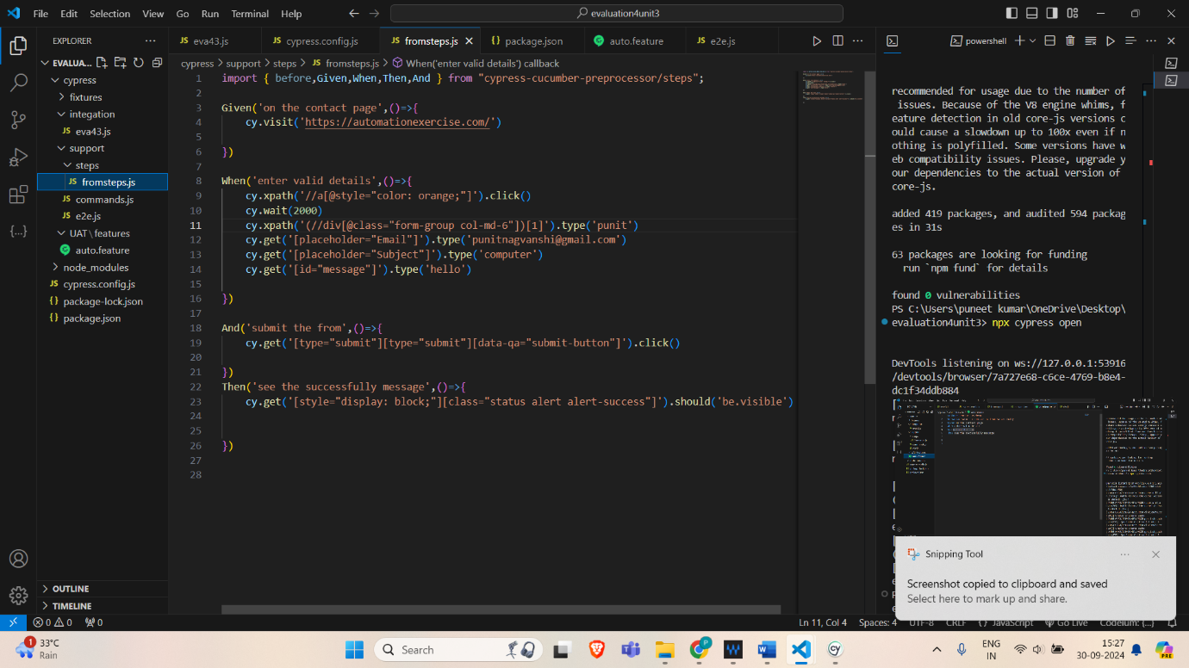

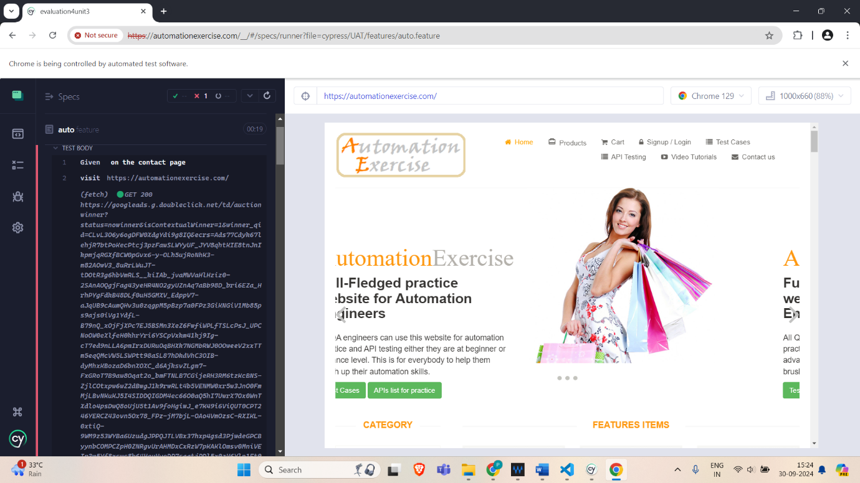

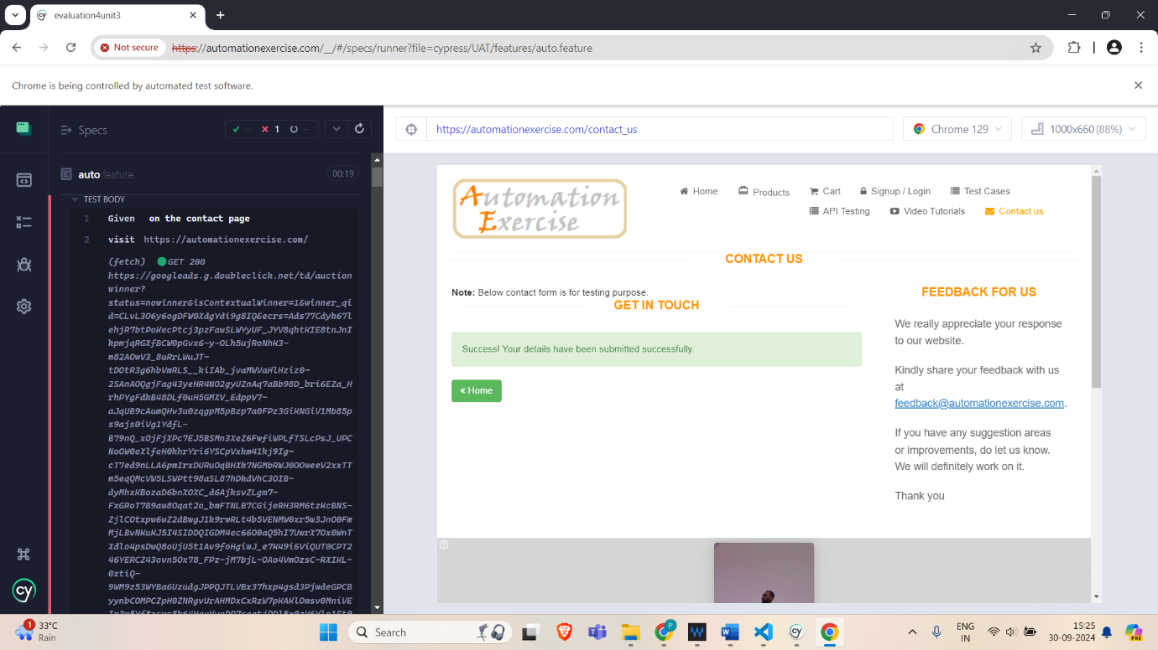

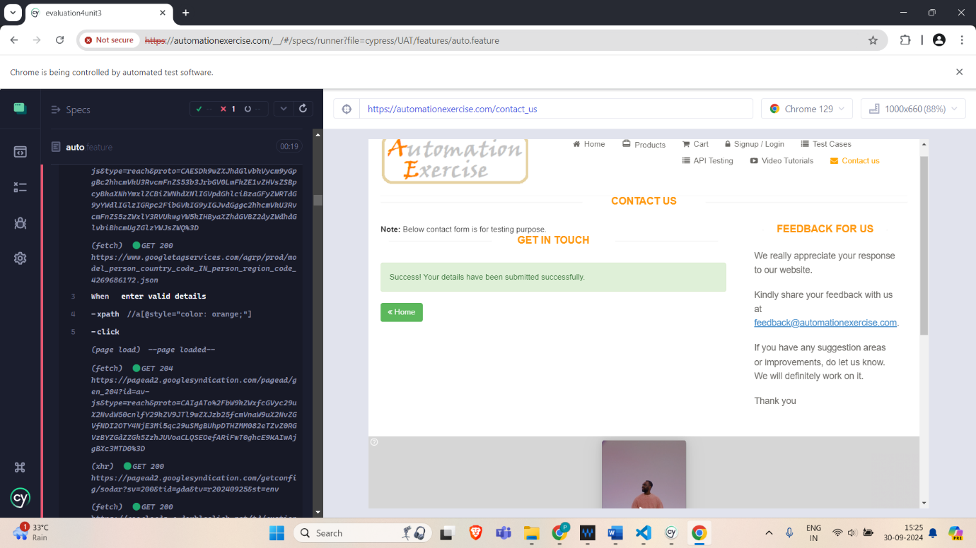

BRUTE FORCE ATTACK

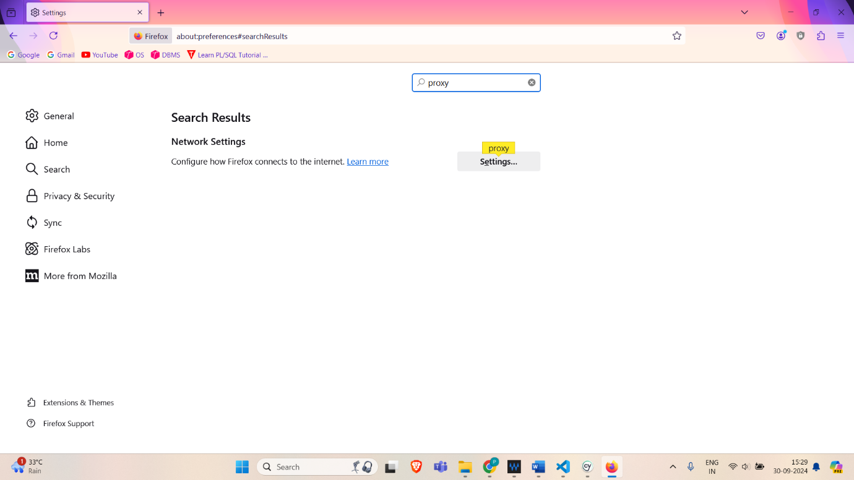

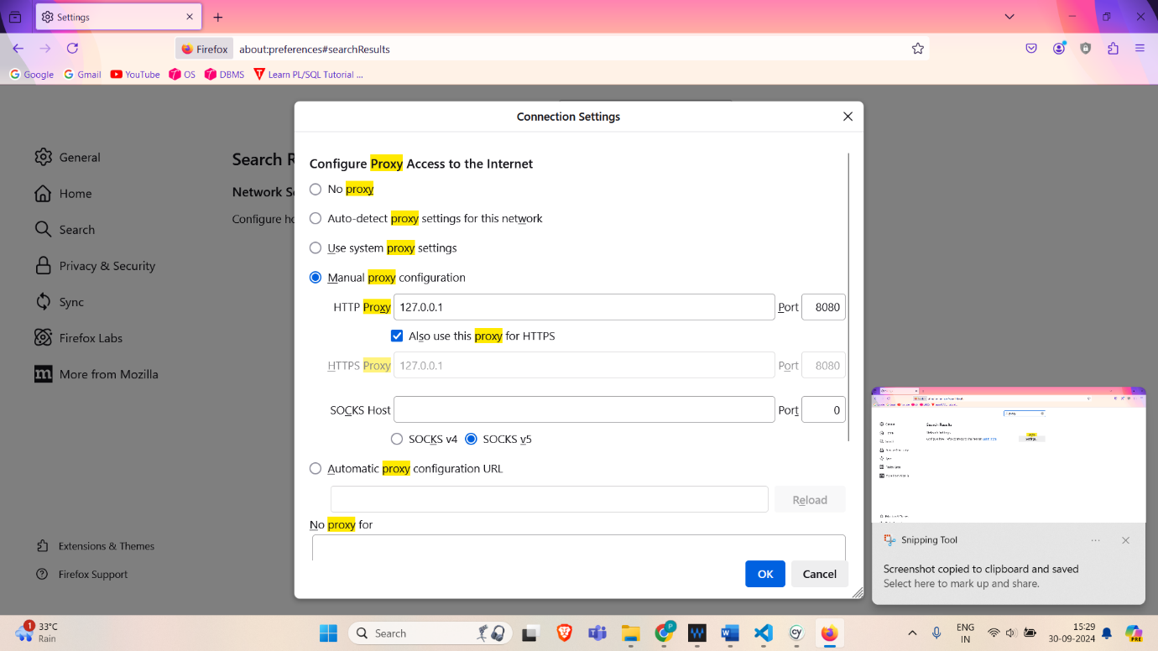

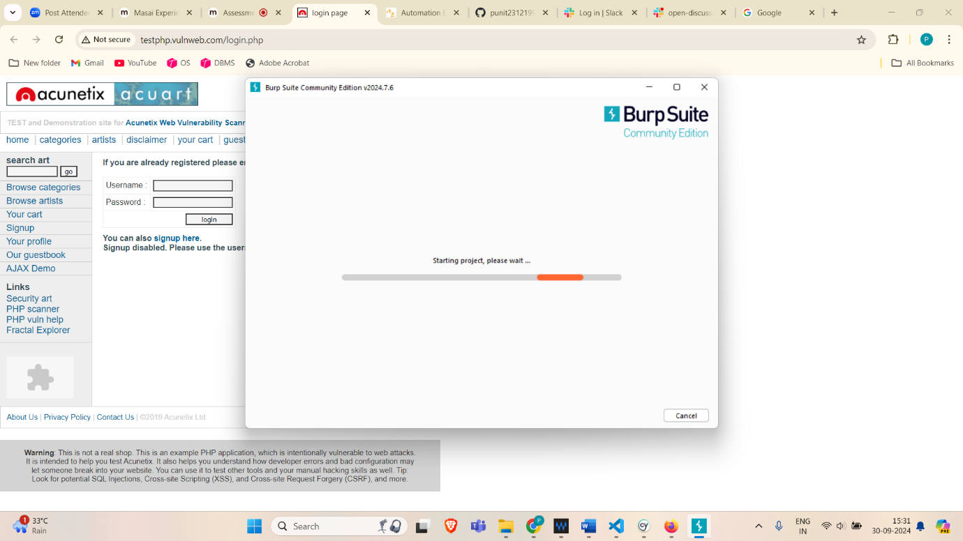

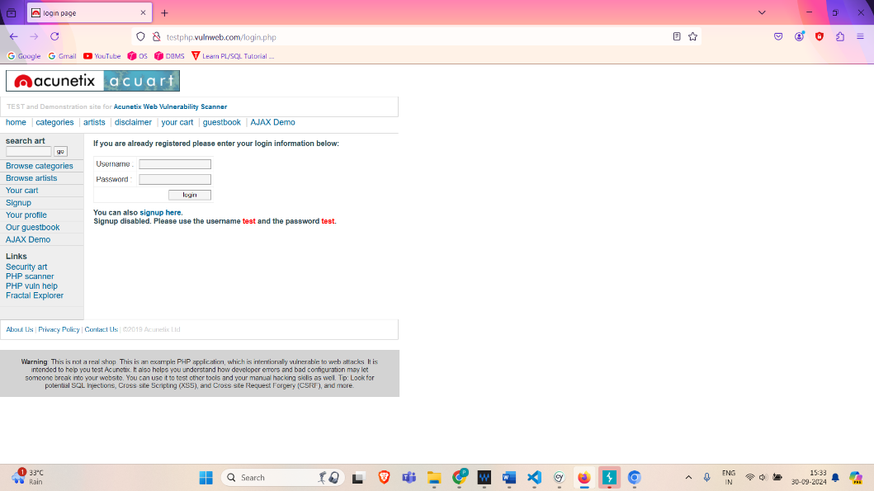

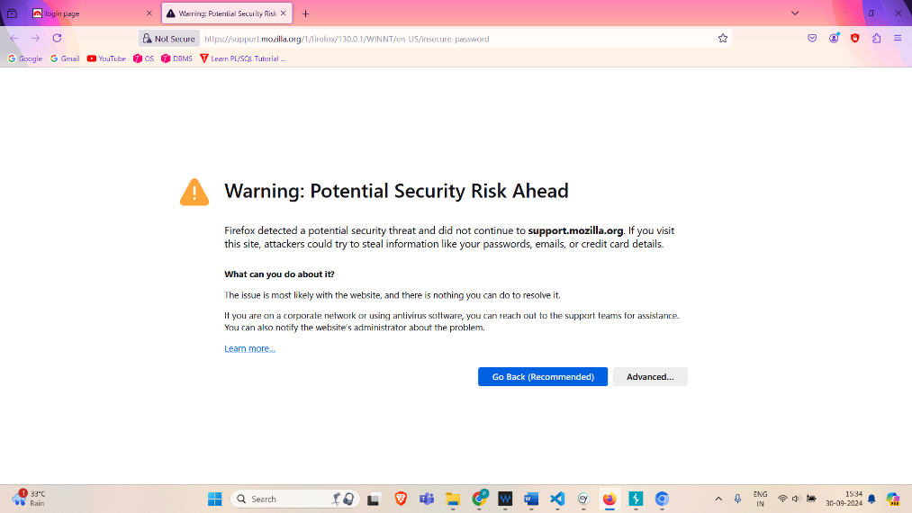

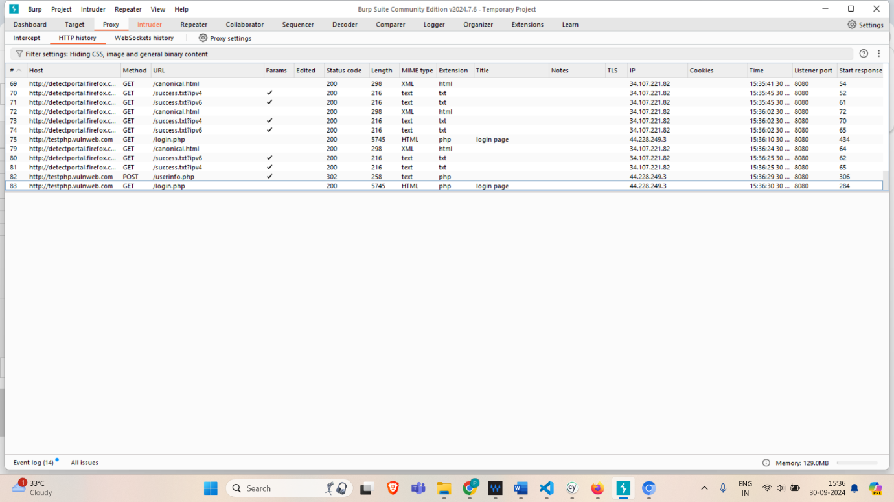

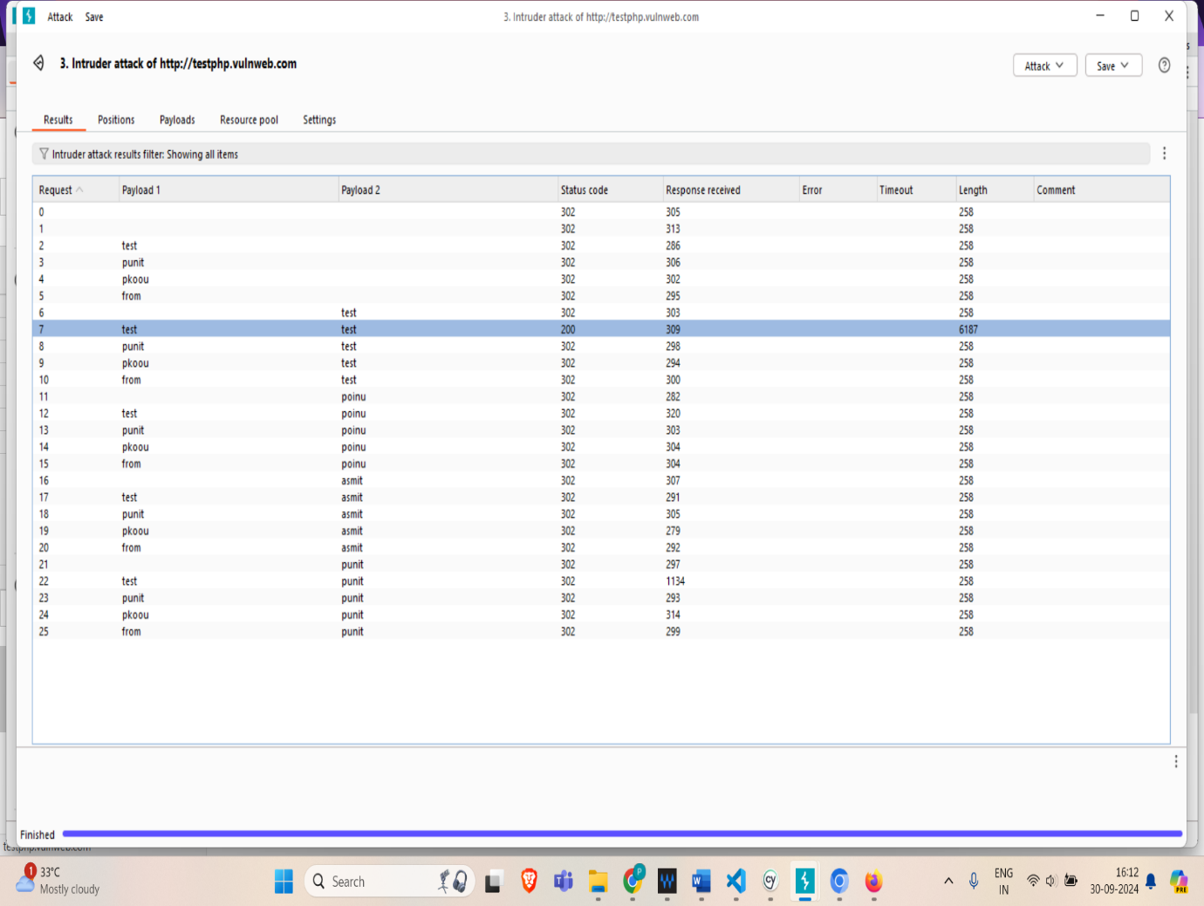

Intruder attack of http://testphp.vulnweb.com